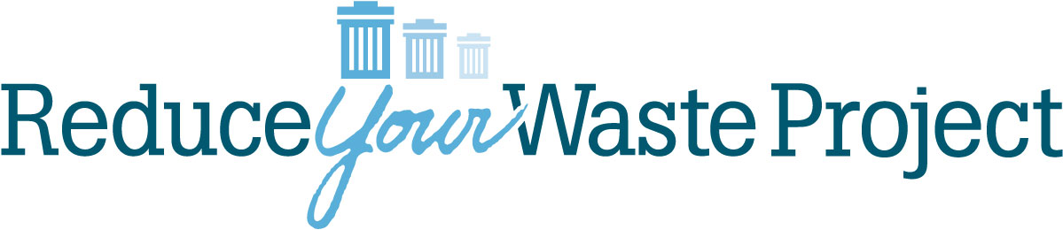
Less is More: Getting to One Can of Garbage a Year
Presented by Betty Shelley, founder of Reduce Your Waste Project
The class is designed to:
- Inform about where our waste comes from and where it goes when thrown away,
- Explain the three Rs -Reduce, Reuse, Recycle - as well as how to avoid waste before it gets to the home,
- Expand awareness of additional Rs,
- Provide an overview of the history of waste,
- Raise awareness of the impacts of water, energy and other resource waste and explore ways to prevent using more than necessary,
- Share techniques for waste reduction, whether it be to one can a month, a quarter or a year,
- Create awareness that individual actions do make a difference, and
- Encourage meaningful discussion through videos, small group sharing, and simple homework assignments.
Objectives:
- Provide methods and practices that reduce and prevent waste,
- Inspire participants to examine their values and behaviors,
- Empower individuals to make simple, step-by-step changes in their daily lives,
- Produce knowledge about the stuff that impacts our lives.
Other information:
- Each session builds on the previous session’s information so attendance at each of the meetings is strongly encouraged.
- Bring whatever materials needed for note-taking.
- Sessions will start and end promptly.
- Bringing food/lunch is acceptable.
- Two documents are provided via email at the end of the class – a list of local resources and a reading list, and a list of some of our waste reduction practices.
- The class is adapted to various settings and group sizes; a minimum number of eight participants is required to ensure lively discussions. The class can be done in one 4- to 5-hour session or can be presented in shorter lengths to accommodate hour-long meetings.
Comments from past participants:
Stacey R.- “The variety of ways you taught the material kept me engaged and focused (you’re a master teacher also). I liked all the exercises, group activities and videos; the power of group learning was quite evident. Your passion and sincerity are quite obvious. I felt I was being taught by someone who walks their talk, enjoys it and was inspiring.”
Margaret B.- “I came out of the class with all sorts of additional information on ways I can reduce my consumption, reduce my waste, and recycle or repurpose or find a good home for things I no longer use.”
Jaylen S.- “I liked the idea that everything comes from the Earth, and the need for reuse and refusal is tantamount. I liked the Re- exercise…Thinking of all the ways we can Re- in our lives was great.”
Liza M.– “It was nice to be in the room with so many other people who care about the environment and are looking at and changing their own impact.”

